**Inception Plan**

**NewWindsorite**

60-611-01 Fall 2016 - Advanced Software Eng Topics

Group 15

Adity Taneja  
Clovis Machado Nogueira Neto  
Precious Akporeha  
Yadwinder Singh

Table of Contents

1. Vision 3

2. Business Case 3

Project Stakeholders/Users 3

3. Use-Case model 3

Outline 3

4. Supplementary specifications 5

5. Glossary 5

6. Risk List 5

Development environment and Management 5

Technical 5

Technology 6

Other potential 6

7. Management Plan 6

8. Prototypes and proof of concepts 6

9. Iteration Plan 6

Phase 1 – Due October 28th 6

Phase 2 – Due November 6th 6

Phase 3 – Due November 17th 6

10. Phase Plan and software development plan 7

11. Development Case 7

12. References 8

# Vision

It generally takes time for a newcomer to settle down and getting accustomed to available services in the town. On most of the city websites there is data available in raw form. With this arises a requirement to bring forth these services with an ease to these people. The project goal is to provide easy and immediate information to newcommer not being necessary to research and find the information from the City’s website. Based on newcomer preferences and characteristics, a new system would be developed that should provide information based on the available raw data, for example, Open data from the City of Windsor.

# Business Case

For any newcomer, there would be certain issues faced by them such as getting accustomed to the general public services in the city of Windsor. Moreover, a newcomer would lack acquaintances to support while they transit to a new city like Windsor. Therefore, the proposed solution would help in the eradication of the above mentioned issues.

The system would provide a user friendly web application which can interact with the new windsorite to provide the public services in real time. A new system would be developed that should recommend various services of the City of Windsor to its registered users. The system is a comprehensive guide to the newcomers at the city of Windsor. This is an interactive website that would gather the user characteristics and preferences of the user and recommend some of the public services as an acquaintances.

Project Stakeholders/Users

* All users that maybe interested to get detailed and public information provided by the City of Windsor Open Data System such as, garbage collection, road blocks Parties and others.
* The City of Windsor Open Data team that is supporting the development with all recent APIs to access the data.
* All the system developers from the Group 15.

# Use-Case model

## Outline

* User Registrations and profile
* Watson based Chatbox for gathering characteristic and preferences of the user.
* Watson to update the characteristic and preferences of the user.
* Recommendation page of a user.
* Recommendation updates through emails.
* Recommendations include information about Garbage collection, Roadblocks, hospital , school , libraries in Windsor.
* Administrator account

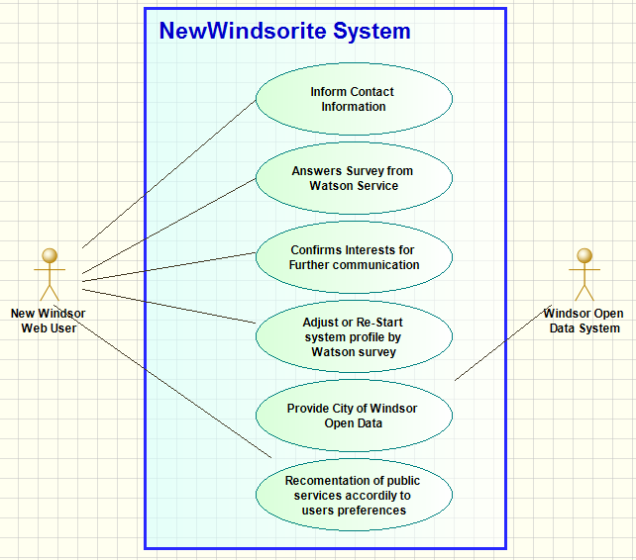



# Supplementary specifications

Key and mostly non-functional requirements with impact on the architecture

Extending of the new API's introduced by the city of Windsor.

Maintain and retrieval of users of the website.

# Glossary

A list and dictionary is extremely important in order to guarantee that everyone envolved in the project will have a clear understanding oof some of the key words.

IBM WATSON - IBM Watson is a technology platform that uses natural language processing and machine learning to reveal insights from large amounts of unstructured data.

CloudantDB - Cloudant is an IBM software product, which is primarily delivered as a cloud-based service. Cloudant is an [open source](https://en.wikipedia.org/wiki/Open_source) non-relational, distributed database service of the same name. Cloudant is based on the [Apache](https://en.wikipedia.org/wiki/Apache_Software_Foundation)-backed [CouchDB](https://en.wikipedia.org/wiki/CouchDB) project and the open source [BigCouch](https://en.wikipedia.org/wiki/BigCouch) project.

DevOps - It aims at establishing a culture and environment where building, [testing](https://en.wikipedia.org/wiki/Software_testing), and releasing software can happen rapidly, frequently, and more reliably. [1]

RESTful – Representational state transfer (REST) or RESTful [web services](https://en.wikipedia.org/wiki/Web_service) are one way of providing interoperability between computer systems on the [internet](https://en.wikipedia.org/wiki/Internet). REST-compliant web services allow requesting systems to access and manipulate textual representations of [web resources](https://en.wikipedia.org/wiki/Web_resource) using a uniform and predefined set of [stateless](https://en.wikipedia.org/wiki/Stateless_protocol) operations. [2]

Open Data – Open Data is a basico repository of data on basic serices provided by the citieis in this case, the City of Windsor. The Data Cataougue contains data about hospitals, roads, garbage collection, bike lanes, community centres and many others.

Windsorite – The newcommers to the city of Windsor.

GitHub – Remote

# Risk List

The risk list bellow contain the identified risks that can be early identified by the team. Managing the risks tend to maximize our changes to have a succesfull project so that a plan on how to manage them can also be built.

Risks are categorized as below.

## Development environment and Management

* Is the team familiar and ready to manage the project with the project management tools available?
* Project will be developed and deployed in BlueMix, IBM cloud based environment
  + Team should gain the necessary knowledge in time.
  + Is the available help resources and technical support going to be enough and fast enough to meet our developers needs?
* Regarding the source and version controle process
  + Do all developers have the minimun necessary experience to upload and manage their work into the share Git repository?
  + Do all developers understand the basic concept of versioning and branches with Git system?

## Technical

* Does the team have basic knowledge of the basic services and APIs that will be used from BlueMix?
* Is there any tool to support software planning and activities tracking?
* Will the team have the experience to use DevOps in order to have continuosly and automatic system build and deployment?
* Will Watson API/Service provide the expected results in order to system actually offer the desired result?
* Is the NoSql techology appropriate for the project or traditional Relational SQL should be adopted?

## Other potential

* Schedule, resources, and product definition are clear to everyone envolved in the project?
* Schedule maybe optimistic once most of the adopted technologies are new to the developers.
* Do the team members have the right kind of skills
* Development tools do not offer enough documentation in order to facilitate developers to improve programing time.
* The team is involved in other project and might not have enough available time.

# Management Plan

# Prototypes and proof of concepts

# Iteration Plan

## Phase 1 – Due October 28th

* Initial analisys along with use-case diagram and system functional flow
* Definition of technologies and development platform
* Elaboration of prototype and proof of concept
* Inception Plan
* Basic development enviroment configured and deployed

## Phase 2 – Due November 6th

* Front end development based on the proof of concept.
* Backend development
  + Database and basic services connections and hadlers working
  + Basic comunication with front end and back end.
* Elaboration of prototype and proof of concept.
* Final report start /Project presentation start

## Phase 3 – Due November 17th/27th

* Project presentation finalization.
* Full prototype working with basic functions

# Phase Plan and software development plan

The team is composed of the following developers:

* Adity Taneja
* Clovis Machado Nogueira Neto
* Precious Akporeha
* Yadwinder Singh

Regarding tools, based on the tecnologies defined to be used to develop the Project, below is the list of tools that will be used by the development team.

* IBM bluemix as Paas
* Devops for tracking and CI
* Git for SCM
* Eclipse as IDE
* Cloudant DB

All development will be equality shared with everyone being part of team and contributing to the whole development process. Eventhough, according the team’s technical specialities and experience Aditya and Precious will majorly focus on the GUI and front-end functionlities. Yadwinder and Clovis will work on the back-end part.

As for the chalanges, new tools and techonologies the team will constantly access the Bluemix support and Bluemix online documentation.

# Development Case

* Development Case– Customization of UP steps and artifacts for the project

**Need to decide the Agile steps here.**

We will maintain stories.

1. Create the welcome page.
2. Create the user authentication system
3. Create user profile .
4. Watson chat box.
5. User recommendation system.
6. Cloudant to save user data .
7. City of Windsor Api implementations.

# References

[1] <https://en.wikipedia.org/wiki/DevOps>

[2] <https://en.wikipedia.org/wiki/Representational_state_transfer>